Experiment: Gaussian Blur
Aim

To read an image in Python and convert it into a blurred image using Gaussian Blur.

Procedure

- Import the OpenCV library.
- Read the input image.
- Apply Gaussian Blur to the image.
- Display the original image.
- Display the blurred image.
- Close all image windows.
Code

import cv2
image = cv2.imread("sample.jpg")
blurred_image = cv2.GaussianBlur(image, (15, 15), 0)
cv2.imshow("Original Image", image)
cv2.imshow("Gaussian Blurred Image", blurred_image)
cv2.waitKey(0)
cv2.destroyAllWindows()
Input
A color image named sample.jpg.
Output
The original image and Gaussian blurred image are displayed.
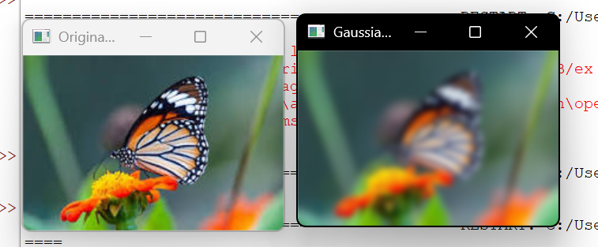
Result
The given image was successfully read and converted into a blurred image using Gaussian Blur in Python and OpenCV.

